|  |  |
| --- | --- |
| **Name** | Umar Hayyat |
| **Roll No** | 360 |

**Lab No #3**

**Introduction to print statement**

**Objectives:**

1. How to use while and for to determine repetition of integer.
2. How to print multiple of 5 in the range defined by user using while and for loop.
3. How to print factorial of number by using for and while loop.
4. How to take number from user and determine whether or not it is palindrome.

**Task no 1:**

Implement a program that prompts the user to enter 10 integer (there can be repetition).The program will count the numbers of times the user enter the integer ‘2’.The count will be displayed on the output screen. Implement using for loop.

**Code:**

count=0

for i in range (10):

a=int(input("please enter number"))

if(a==2):

count=count+1

print("number of times user entered 2 is",count)

**Output:**

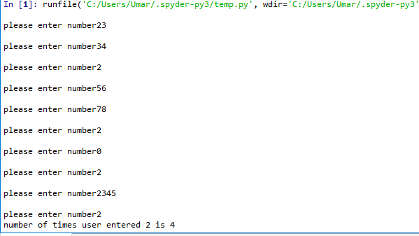

**Task No 2:**

Implement a program that print multiple of 5 in the range defined by user such that only 5 number are printed on one row. Implement using both while and for loops.

**Code:**

a=int(input("please provide lower range"))

b=int(input("please provide upper range"))

count=0

i=a

for i in range (i,b):

if(i%5==0):

print(i,end='\t')

count=count+1

if(count==5):

count=0

print('\n')

**Output:**

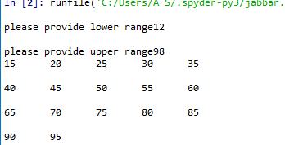

**Task #3:**

Take a number from user and print its factorial. Implement both for and while loop.

**Code:**

a=int(input("please enter number"))

factorial=1

for i in range (1,a+1,1):

factorial=factorial*i

print(factorial)

**Using while loop**

a=int(input("please enter number"))

factorial=1

while(a>0):

factorial=factorial*a

a=a-1

print(factorial)

**Output:**

**For loop**

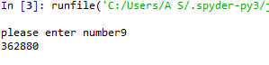**While loop**



**Task#4:**

A palindrome is a number or a test phrase that read the same backword as forward. For example each of following integer is a palindrome 12321,55555,45554 and 11611. Write a program that read 5 digit integer and determine whether or not it is palindrome.

**Code:**

a=int(input("please enter a 5 digit number"))

b=a%10

c=int(b/10)

d=c%10

e=int(d/10)

f=e%10

g=int(f/10)

h=g%10

i=int(h/10)

j=(i%10)

k=int(j/10)

reverse=b*10000+d*1000+f*100+h*10+j

if(a==reverse):

print("it is palindrome")

else:

print("it is not palindrome")

**Output:**

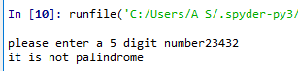

**Conclusion:**

I learnt how to use for and while loop.I also learnt how take number from user and show it factorial.